ASSIGNMENT 15
1) Assume there is a table called Multicust, with all of the same column definitions as Salespeople.
Write a command that inserts all salespeople with more than one customer into this table.

create table Multicust as select *from SALESPEOPLE where Snum In(select CUSTOMERS.Snum from SALESPEOPLE ,CUSTOMERS where SALESPEOPLE.Snum = CUSTOMERS.Snum group by CUSTOMERS.Snum having Count(CUSTOMERS.Snum)>1);
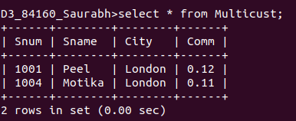

2) Write a command that deletes all customers with no current orders.

delete from CUSTOMERS where Cnum not in (SELECT Cnum from ORDERS);

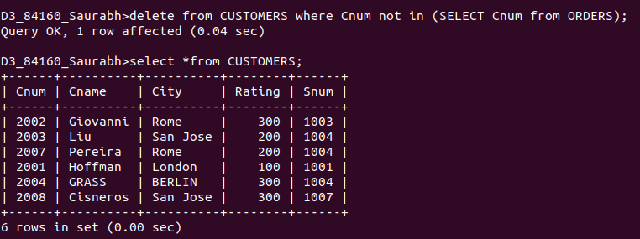

3) Write a command that increases by twenty percent the commissions of all salespeople with
total orders above Rs. 3,000.

update SALESPEOPLE set Comm = Comm + (Comm*0.2) where Snum In (select Snum from ORDERS group by Snum having sum(Amt)>3000);

